**Astronomy and Statistics**

Online Interactive Maps

* <https://nso.edu/for-public/eclipse-map-2024/>
* <https://eclipse2024.org/eclipse_cities/statemap.php>
* <https://stellarium-web.org/>
* <https://www.solarsystemscope.com/>
* <https://earthobservatory.nasa.gov/features/OrbitsHistory>

The History of Statistics: The Measurement of Uncertainty before 1900 by Stephen M. Stigler

* <https://www.britannica.com/science/astronomy/History-of-astronomy>
* Calendars - <https://en.wikipedia.org/wiki/History_of_calendars>
  + <https://imagine.gsfc.nasa.gov/science/toolbox/timing_history.html>
  + Antiquity were lunisolar, based on moon phase and position of the sun
  + Julius Caesar made reforms (Julian calendar) based on an algorithm of introducing a leap day every four years but added an extra day every 128 years causing seasonal equinoxes to fall at wrong time of year
  + Gregorian (Pope Gregory XIII 1582) is now defacto
* <https://en.wikipedia.org/wiki/Least_squares#History>
* Astronomical Collections
  + <https://en.wikipedia.org/wiki/Tycho_Brahe>
  + <https://observablehq.com/@christophe-yamahata/visualizing-tycho-brahe-s-astronomical-observations-mars>
  + <https://library.si.edu/digital-library/book/tychonisbraheas00braha>
  + <https://library.si.edu/digital-library/book/tychonisbrahedan00brah>
  + <https://www.sciencephoto.com/media/720385/view/table-from-the-rudolphine-tables-1627->
  + <https://early-astronomy.classics.lsa.umich.edu/western_rudolphine.php>
  + <https://www.loc.gov/item/85194777/>
  + <https://www.loc.gov/resource/rbc0001.2013gen94777/?c=40&sp=3&st=gallery>
  + <http://www.sites.hps.cam.ac.uk/starry/logarithms.html>
  + <http://www.sites.hps.cam.ac.uk/starry/keplertables.html>
  + <https://telescoper.blog/2015/08/29/statistics-in-astronomy/>
* Legendre (1805 - Least Squares)
  + New Methods for the Orbits of Comets (Least Squares)
  + E = a + bx + cy + fz + &c.,
  + A, b, c, f, &c known coefficients; the rest are unknown and determined by E (the error)
  + Multiply terms by coefficient of the unknowns and add it all up
  + <https://en.wikipedia.org/wiki/Least_squares>
  + <https://www.cuemath.com/data/least-squares/>
* Cotes Rule
  + Errors decrease with aggregation rather than increase
* Tobias Mayer and Euler
  + Method of averages - combination of different observations under same equations
  + The inequalities of the motions of Jupiter and Saturn
  + The librations (the moon’s face varies, wobbles) of the Moon
  + Latitude measures angular elevation above horizon
  + Longitude based on Moon features and position with stars
  + Created a table of equations of condition
  + Uses the symbol plus/minus x (margin of error?)
  + Let error be the limit of accuracy for the mean
  + Post 1750 mathematical astronomers averaged simple measurements, combining several days of observations into a single number, as well as doing the same with equations
* Laplace
  + The Mechanics of the Planets
  + Analytical Theory of Probability
  + Mayer’s 27 equations of conditions of moon crater observations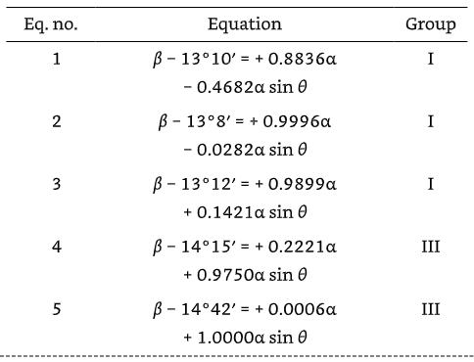
  + Laplace’s Saturn Data with residuals - <https://www.britannica.com/biography/Pierre-Simon-marquis-de-Laplace> 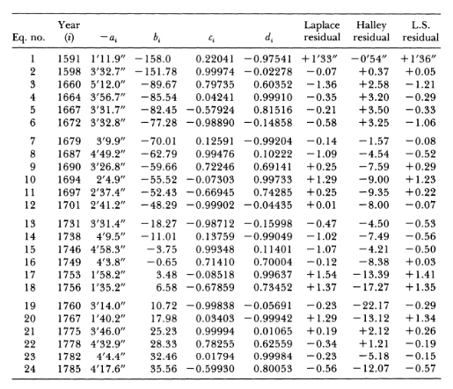
  + To resolve inconsistencies he reduced the 24 equations by
    - Sum of equations
    - The difference of the sums
    - Linear combinations of equations
  + Probability density for errors - Laplace distribution (two-sided exponential distribution)
  + <https://en.wikipedia.org/wiki/System_of_linear_equations>   
    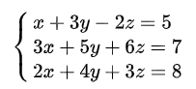  
    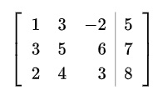  
    Row reduction, Gaussian Elimination
* Roger Boscovich
  + Least Absolute Deviation - the combination of different observations under different conditions
* Legendre (Least Squares Method)
  + The first clear and concise exposition of the method of least squares was published by Legendre in 1805. The technique is described as an algebraic procedure for fitting linear equations to data and Legendre demonstrates the new method by analyzing the same data as Laplace for the shape of the Earth.
* Jacob Bernoulli
  + Ars Conjectandi - the formalization of the mathematical theory of probability
  + Law of large numbers - the greater the number of observations the less the uncertainty in the result
* De Moivre - stated and proved the normal approximation to the Binomial distribution
* Simpson
  + Development of quantified uncertainty and mathematical theory of inference
  + A new problem was to combine discordant observations, if five observers record five different times for the passage of a star past a crosshair in a telescope, how are these numbers reconciled?
  + Introduces annuity tables (insurance)
  + Wrote a letter on the advantage of taking the mean of a number of observation (astronomical)
  + Distribution of errors accounts for small and large errors
  + Simpson’s Paradox - a trend that appears in multiple groups may disappear when the groups are combined
* Inverse Probability (Bayesian Inference, inferential statistics), probability distribution of an unobserved variable
* Fisher - fundamental paradox of inverse probability is the source of confusion between statistical terms that refer to the true value to be estimated with the actual value arrived at by the estimation method, which is subject to error
* Choice of Means
* The Error Curve of 1777 - <https://www.qualitydigest.com/inside/six-sigma-article/distribution-measurement-error-040323.html>
* Bayes (Binomial) - <https://en.wikipedia.org/wiki/Binomial_distribution>
* Laplace (Central Limit Theorem)
* Gauss
  + The motion of planetoids are disturbed by the larger planets
  + <https://www.actuaries.digital/2021/03/31/gauss-least-squares-and-the-missing-planet/>
* The Gaussian distribution came about from Laplace’s distribution of errors when sampling the mean, Gauss’ observation of measurement error and de Moivre’s attempt to approximate the binomial distribution with largeaN